Erasmus + "I am not a target” 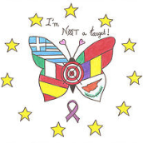
Educational Project
"STOP BULLYING"
April 2020

Project elaborated by
Teachers of EB da Cova da Piedade

Education Project
“Stop Bullying”
April 2020
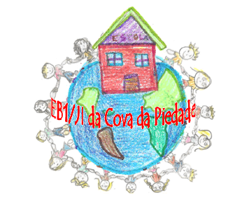

Escola Básica da Cova da Piedade
AE Emídio Navarro
Cova da Piedade/Almada

- Argument
The choice of the project for the month of April focuses on collaborative work between teachers, as it is not limited to the mere decoding, implementation and completion of the guiding documents of the groupings. This bridge will be built as the joint structuring of teachers and students.
In order to embark on this learning strategy, it is important to be aware of its true meaning, therefore, in order to respond to the fulfillment of the activities of the month of April, we chose to suggest works that reflected the organic of our school, making an intersection with the values ​​underlying the Erasmus + project “I am not a target”:
- Cooperative and collaborative work among students, in an autonomous and self-help development process, as active subjects of learning and co-responsible for the development of the group;
- The culture of an inclusive school, based on different educational responses that are appropriate to the pace and abilities of each student, with full respect for difference, promoting the achievement of students as people;
- The integration and coherence between teaching, learning and assessment, in a logic of self-regulation of the students' evolutionary path and encouraging learning; the unique participation of parents and guardians and students in the life of the project;
- The diversification and optimization of the information and internal communication circuits, with positive impacts on the internal organization of the School and on the image it projects to the outside.

- Objectives of the project
Therefore, and in accordance with the provisions of DL 55/2018 “of Implementing the Citizenship and Development component, as a work area present in the different educational and training offers, with a view to the exercise of active citizenship, of democratic participation, in intercultural contexts of sharing and collaboration and confrontation of ideas on current issues”; and duly justified by the values of the Erasmus + project “I am not a target”.

- Target Group
All students from kindergarten to 4th grade.

- Direct and indirect beneficiaries
Direct: Students, teachers, parents.
Indirect: Community

- Project Duration
April 2020

- Place of Performance
Classrooms, Library, Gym and Schoolyard

- Materials
Recyclable material; Cardboards; Markers; thematic videos; Placards; Physical education material; Interactive board…

- Activities
All classes, from kindergarten to 4th year, will carry out the suggested challenges, which after the respective pedagogical procedural correction culminate in the elaboration of a work sharing exhibition. Not neglecting individual work, where students can express their emotions, thoughts and reduce or enlarge them to the size of letters or images, there will subsequently be an intersection between individual and collective ideas.

Groups / Classes | Activities | Place | Timetable
Pre-school | -Practical work alluding to affections  (with the collaboration of families - exhibition of works at school) | Classroom  Polyvalent | April 2020
1st class | -Practical work alluding to affections  (with the collaboration of families - exhibition of works at school) | Classroom  Polyvalent | April 2020
2st class | -Exploring books / films about affections and / or bullying  (Preparation of works - exhibition of works at school) | Classroom  Library  Polyvalent | April 2020
3st class | - Game: Role-play cards: Bully tactics! - Opinion time - Group work (*See attached)  - Preparation of works with positive messages to be posted on school panels. | Classroom  Library  Polyvalent | April 2020
4st class | - Conflict Resolution Brigade. (creation of groups of students responsible for helping colleagues in conflict resolution)  - Preparation of a brochure with conflict resolution tips. | Classroom  Courtyard  Library  Polyvalent | April 2020

- Conclusion
Affective / rational awareness of the construction of children's thinking is undoubtedly the best vehicle for mobilizing learning.
Respect for the difference of the other, while being unique and unrepeatable, together with their acceptance as equal, in their humanity. These will be the basis for building a multicultural and inclusive citizenship, which can (and must!) be learned from an early age.
We conclude that despite the need for constant “autoscopy” of our pedagogical practices, this project has the following positive aspects:

- Sharing and increasing knowledge;
- Task distribution and shared leadership;
- Acceptance of criticism and more power of argument;
- Increased self-esteem;
- Less problems and conflicts.
* Role-Play Cards: Bully Tactics!
